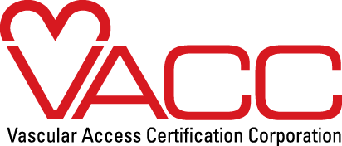

Dear ,

I’m currently due for my VA-BC™ Recertification. As someone who is accountable for vascular access practice in our organization, I feel that it is important to have a certification that reflects this. The organization’s support for certification demonstrates a commitment to best practices in vascular access and meets the demand for high patient safety standards.

The VA-BC™ credential is valid for 3 years and is accredited by the National Commission of Certifying Agencies (NCCA) as a multidisciplinary certification. The VA-BC™ is also recognized by American Nurses Credentialing Center (ANCC) for Magnet status.

Because this recertification will continue to enable me to validate mastery of the specialized knowledge in vascular access, I am seeking sponsorship for the application fee.

The fee for my recertification will be $_____.

(Recertification fees found here: http://www.vacert.org/dates-fees/ )

I sincerely hope that I’m given the opportunity to renew my VA-BC™ and reap the benefits that this certification has to offer. Because I would like to make sure that I register in time for the discounted Early Bird Registration, I would greatly appreciate a response by <insert date; early bird registration deadline is March/September 1, XXXX>The month will depend on if you plan to take the exam in June or December.

Thank you in advance for consideration of this opportunity.

Regards,

Your Name

